Clearwater Soil and Water Conservation District
FY 2018 Fact Sheet

General Information
The Clearwater Soil and Water Conservation District was organized in 1946 to provide educational, technical and financial assistance to local landowners and operators, to conserve soil, water and related natural resources. Clearwater County’s acreage is 94% forested.
Mission
Provide local leadership to educate and assist the public on wise stewardship and management of soil, water, air, plant and animal resources, and to promote strong conservation partnerships to find practical, economical solutions to natural resources problems and coordinate their implementation.
Location
Clearwater County- 1.6 mil acres in North Central, ID.
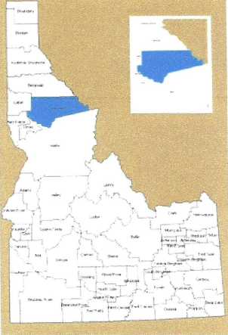
Legislative District 1
FY 2018 Accomplishments
- Partnered with USFS and PotlatchDeltic on EPA 319 Washington Creek Culvert Replacement Project. The project replaced two sets of culverts with two bridges, 44 & 68 ft long. Fish passage is improved and the risk of catastrophic road failure is reduced on this Class 1 Stream.
- Replaced 20 undersized and damaged culverts in the Quartz Creek drainage. This project was funded with an IWRB Flood Management Grant.
- In partnership with the Community Hazard Mitigation Team and the State Firewise Program Manager, continued to develop a Firewise Program for Clearwater County.
Future Plans and Projects:
- Replace all 28 outdated culverts on Bingo Creek.
- Install a 70 foot bridge to replace an undersized culvert on Scofield Creek with the assistance of partners: US Forest Service and PotlatchDeltic.
- Maintain an active presence on the Community Hazard Mitigation Board.
- Work with local, Fed, and State partners to educate landowners on cost-assistance for fuel-reduction projects.
- Partner in RCPP Jim Ford Watershed Project with NRCS & Idaho Soil & Water Com. for cost-sharing conservation projects with private landowners.
- Participate in the 4th grade Earth Day Classroom.
- Co-Sponsor and participate in the 6th-Grade Forestry and Natural Resource Tour. Capacity Building Funds were used for the 6th Grade Forestry Tour and staff development.

